|  |
| --- |
| [Type the company name] |
| Configuring IIS |
| Windows Server 2008 R2 Enterprise– 64bit |

|  |
| --- |
|  |

# Configuring IIS 7.0

* 1. Click **Server Manager** beside the windows **Start** menu



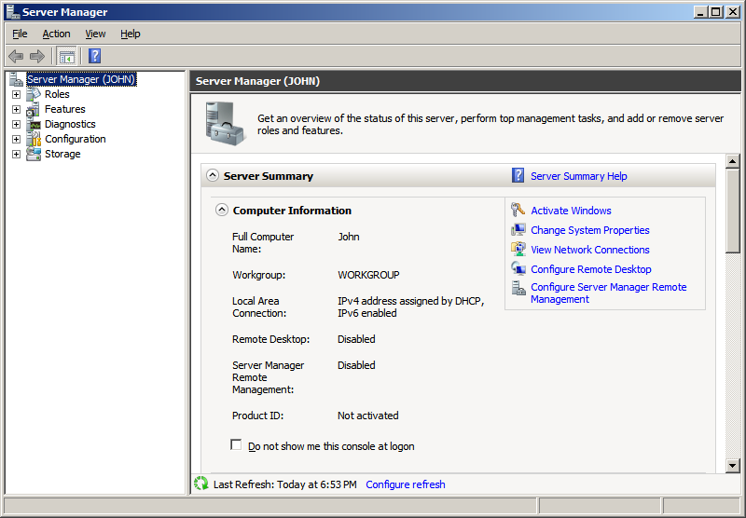

Figure 1: Server Manager

* 1. Click “**Roles**”

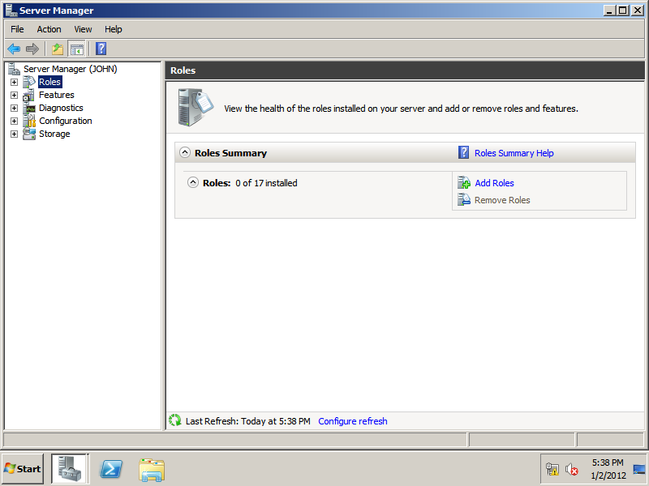

Figure 2 : Server Manager

* 1. Click “**Add Roles**”



Figure 3: Server Manager

* 1. Click “**Next>**”

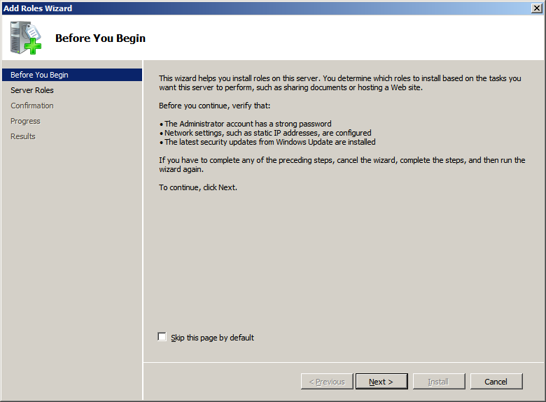

Figure 4 : Add Roles Wizard

* 1. Select “**Web Server (IIS)**” Checkbox
  2. Click “**Next>**”

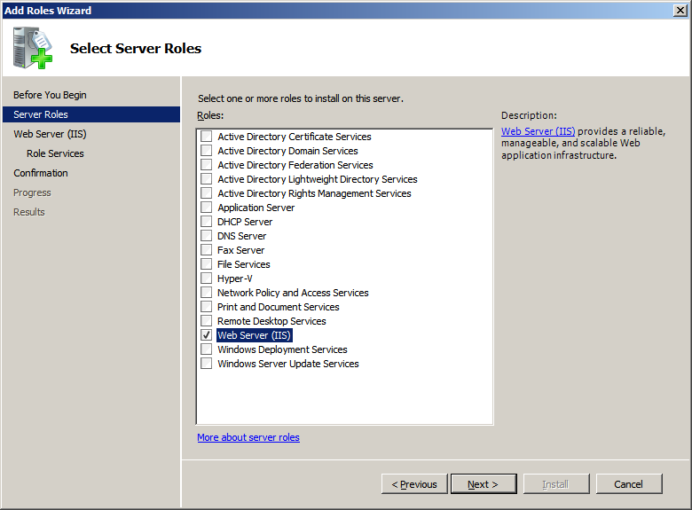

Figure 5 : Add Roles Wizard

* 1. Click “**Next>**”

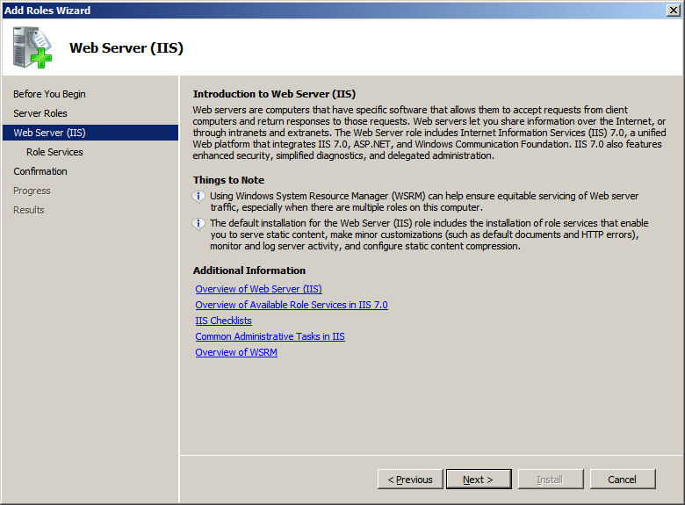

Figure 6 : Add Roles Wizard

* 1. Click “**Web Server**” and expand it by clicking “**+**”
  2. Select “**asp.net**” Checkbox

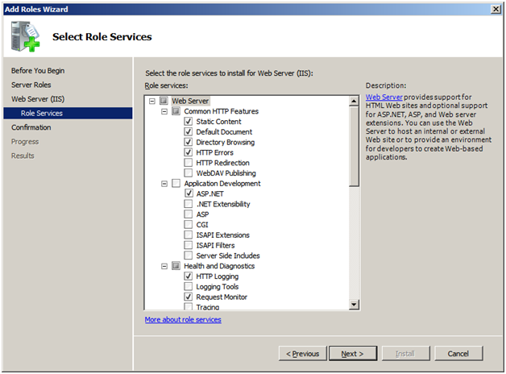

Figure 7 : Select Role Services

* 1. Click “**Add Required Role Services**”

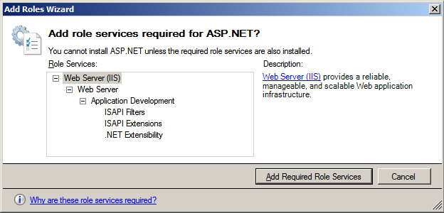

Figure 8 : Add Roles Wizard

* 1. Select “**Management Service**” check box
  2. Select “**IIS 6 management Console**” check box

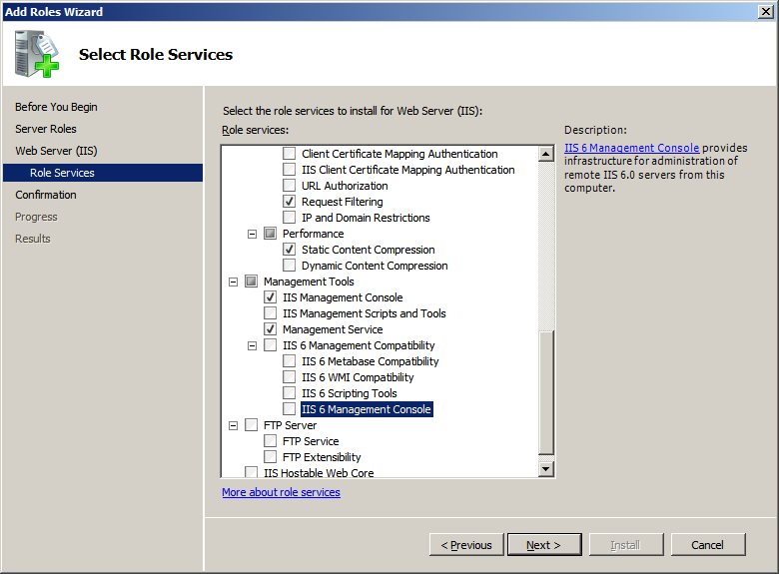

Figure 9: Select Role Services

* 1. Click “**Add Required Role Services**” in dialog box

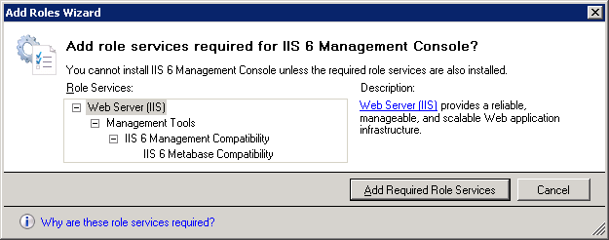

Figure 10 : Add Roles Wizard

***Before proceeding further, please make sure that following options are enabled in IIS 7.***

1. Under Common HTTP Features
   * 1. Static Content
     2. Default Document
     3. Directory Browsing
     4. HTTP Errors
2. Under Application Development
   * 1. ASP.NET
     2. .NET Extensibility
     3. ISAPI Extensions
     4. ISAPI Filters
3. Under Management Tools
   * 1. Management Service
     2. IIS Management Console
     3. IIS 6 Metabase Compatibility
     4. IIS 6 Management Console

* 1. Click “**Next>**”

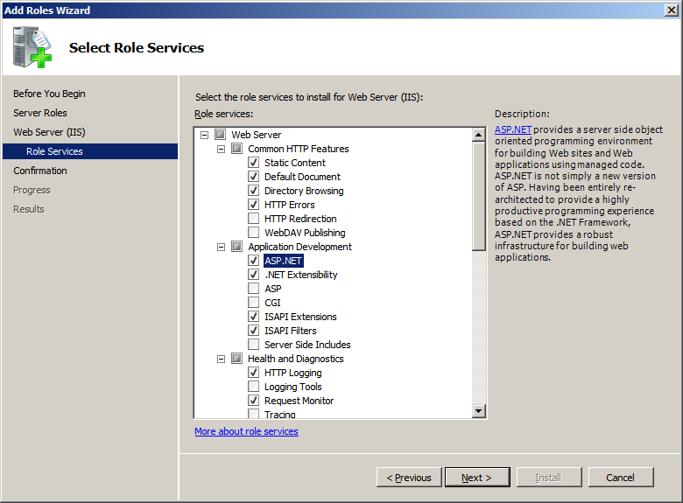

Figure 11 : Select Role Services

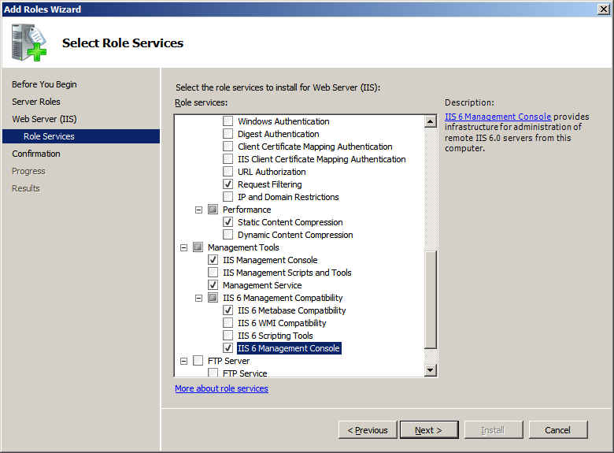

Figure 12 : Select Role Services

* 1. Click “**Install**”

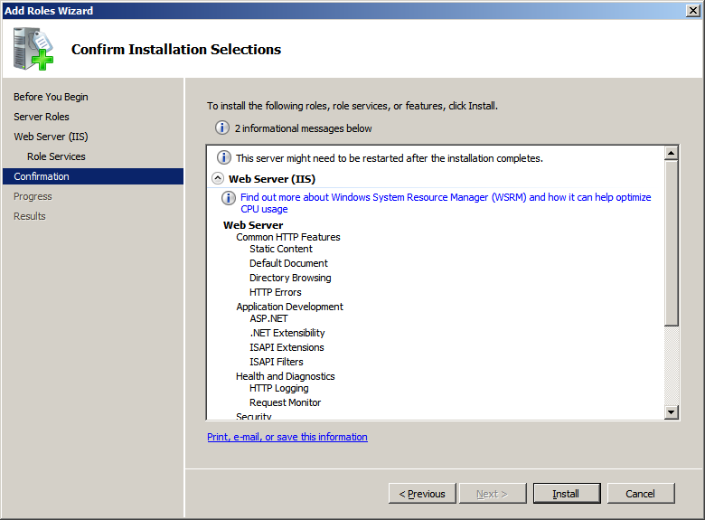

Figure 13 : Confirm Installation Selections

* 1. Click “**Close**”

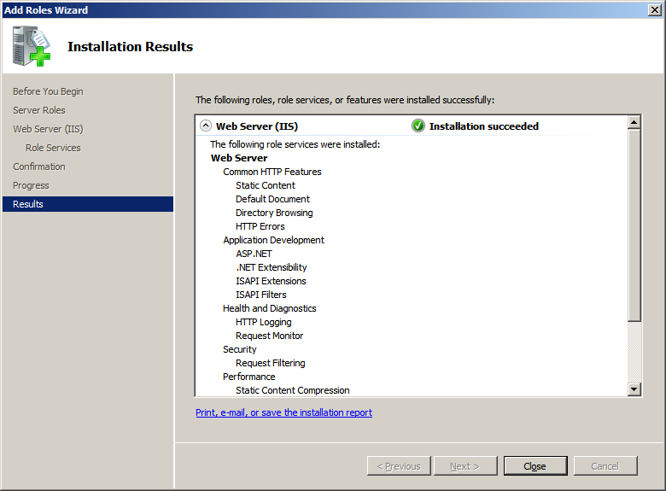

Figure 14: Installation Results